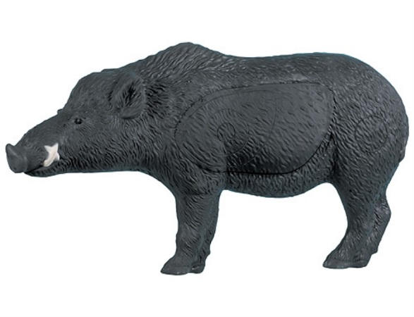
NEWS FLASH!
To mark the 21th anniversary of Bigfoot, The Black Knights are running a very exciting, …….…..Two Man Team 3-D $ Shoot
When: During BIGFOOT on Sunday July 12th at 9AM
Entrance fee will be $ 60 per team with $ 50 going toward payback.
Final payback will be determined by the number of registered teams.
The unique and challenging 3-D course will consist of 30 targets at unmarked distances with max distance being 50 yards. Team members will be allowed to discuss yardage. Best arrow will count for the team score.
No range finders will be allowed.
For additional information or to reserve a spot, please contact
Roger Dean at (609) 713-2701 or radarchery@hotmail.com
IMPORTANT – PLEASE READ
On-site registration will be between 7am and 8:30 am on Sunday.
All shooters MUST attend a short meeting to be held at 8:30.
Registration ends at 8:30 SHARP
Groups will be assigned by officials. Shoot begins at 9:00 am sharp.

